- DOCUMENTS YOU NEED TO PREPARE :

- PASSPORT COPY
- USA VISA PAGE COPY
- US FORM I-94 HTTPS://i94.cbp.dhs.gov/I94/ as per attached below how to get it
- DR LETTER (STATE YOUR WEEK , DUE DATE , NOT ALLOWED TO TRAVEL TILL .. STATE THE PERIOD)
- HOSPITAL PAYMENT RECEIPT
- DOCTOR PAYMENT RECEIPT
- RETURN TICKET AIRLINES
- APARTMENT PAYMENT RECEIPT FOR ALL PERIOD OF STAY
- (Wife & husband)SALAR CERTIFICATE (Addressed to UNITED STATES CITIZENSHIP AND IMIGRATION SERVICES USCIS)
- ( Wife & husband ) BANK statement (salary statement + saving statement)
- Money chq ( to pay fees of your case 360$ ) “ u can go to any western union or big grocery shops with western union and ask or money chq – you will issue it by paying it by cash only
- And fill details as attached chq copy
- Cover letter ( as per below attached)
- Application fill online ( print and sign

Cover letter
DEC 6,2017
USCIS /ATTN: I-539 --EXTENSION OF VISIT VISA NON IMMIGRANT VISA STATUS- B
Dear Sir/ Madam
I am enclosing form I-539 With all supporting documents to extend my visit visa
( non immigrant status in US )
As I entered to US on date : ----------------------------------
Airport – US IMMIGRATION stamped my stay for 20 days only till date : ------------------------
Extension requested till date : ----------------------------------
Below valid applicable reason for extension:
I came to US for visit with my husband and for some shopping, But I have been diagnosed with a medical condition due to my pregnancy, And I visit a Dr and he advised me to stay till I get delivered my baby as it will be risky for me and baby to travel with long distance flight . attached Dr letter.
Please find following documents for your review:
- Application
- Application fees
- Medical report from doctor
- Hospital/Dr fees covered with receipt
- Apartment paid for period staying in US with address
- Copy of airlines return back ticket
- Bank statement for me and my husband ( covered our stay )
- Salary certificate for me and my husband ( stating tht I still working in my country )
- Copy of passport/ US VISA
- Form i-94
At the end, and for the reason of my health condition I kindly request to extend my stay for period mentioned,,,For any question , enquiries please contact me on below
Email:
Temporary number during my stay in US --- US Number :
Permanent number : UAE number
Name /signature

Address / money chq copy

GO to fedex
Print all documents / take copies
Fill application online then send all below to below address : keep copy from documents and fedex air way bill to track your order
Address where to send documents:
USCIS Dallas Lockbox
For U.S. Postal Service (USPS)::
USCIS
ATTN: I-539
2501 S. State Highway 121 Business
Suite 400
Lewisville, TX 75067

Money chq simple :
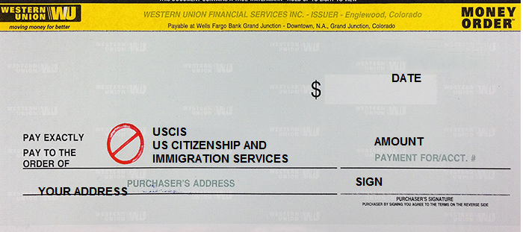

TO GET COPY FROM YOUR I-94 RECORD ( your record of entering US )
https://i94.cbp.dhs.gov/I94/#/home

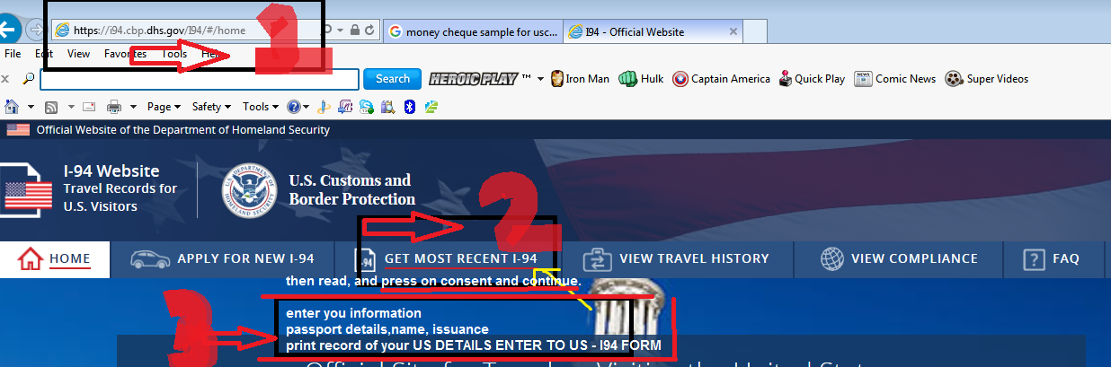

FORM

Agency to help on fill your application
https://www.us-immigration.com/

- Enter site
- US VISA
- FORM I-539
- START YOU APPLICATION
- WILL ASK YOU SOME QUESTION
- ANSWER ALL
- THEN WILL OPEN NEW PAGE TO CREATE USER AND ENTER YOUR DETAILS
- THEY WILL CONTACT YOU
TO PAY AROUND 100$ BY VISA ONLINE
AND THEY WILL CREATE THE APPLICATION YOU NEED TO FILL ONLINE
YOU CAN FOLLOW UP WITH THEM HOW TO FILL ALL INFORMATION WITH THEIR FREE DIRECT NUMBER